Battery Acid and Minor Acid
Spill Clean Up Procedures
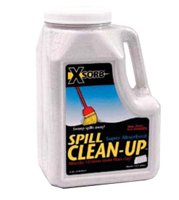Only trained staff may clean up a minor spill.
CHARGING BATTERY
- Never add water to a forklift battery before charging. Wait until it is fully charged and cool. Prior to adding water to the battery, the powered industrial truck operator must wear personal protective equipment (chemical splash goggles, apron, and neoprene gloves) to prevent exposure to battery acid.

CLEANING UP AN ACID SPILL (not for hydrofluoric acid)
- Notify co-workers of spill and restrict access to affected area during clean up.
- Retrieve acid spill kit that includes Xsorb Acid Neutralizing Super Absorbent, personal protective equipment, pH paper, paint stirrer, brush and scoop, and waste disposal bag.
- Wear personal protective equipment: chemical splash goggles, apron, and neoprene gloves.
- Encircle spill with Xsorb and then apply inward. Xsorb should cover entire spill.
- Mix Xsorb thoroughly into the spill using the brush or paint stirrer in a back and forth motion.
- Wait 5 minutes to allow Xsorb to thoroughly absorb and neutralize the acid.
- Using supplied pH paper, tear off a strip and place into absorbed material. Refer to color chart accompanying pH paper to verify pH is neutral (6.5 to 7.2).
- If pH has not reached neutral, rehydrate Xsorb/spill mixture with water and mix in additional Xsorb. Retest with pH strip to verify a neutral pH has been achieved.
- Place waste absorbed material into waste disposal bag, using brush and dust pan and dispose of in regular trash. Keep goggles for reuse if possible.
- For a replacement spill kit or any contents, contact EH&S at 4-6783.

For a major spill or if you need assistance:

In University Hospital: Call University Police, 911

In Hospital Off Site Facilities: Call 911

